**Practical Activity 5**

Sally Oketch.

[Sally.oketch@womentechsters.org](mailto:Sally.oketch@womentechsters.org)

Assuming you are a system administrator in “CarMax” Car Dealership and you have been assigned with a task to add 1 Headquarters and 2 Sales Locations in a windows Server 2016 you configured.

1. **With the help of Active Directory, Add the Headquarters and 2 Sales Locations.**

Go to the active directory users and computers tab and create an organizational unit called CARMAX inside it I have the HEADQUARTERS and two different locations which I named Kisumu and Nairobi.

In HEADQUARTERS three organizational units to represent Administration department, Accounting department and HR. 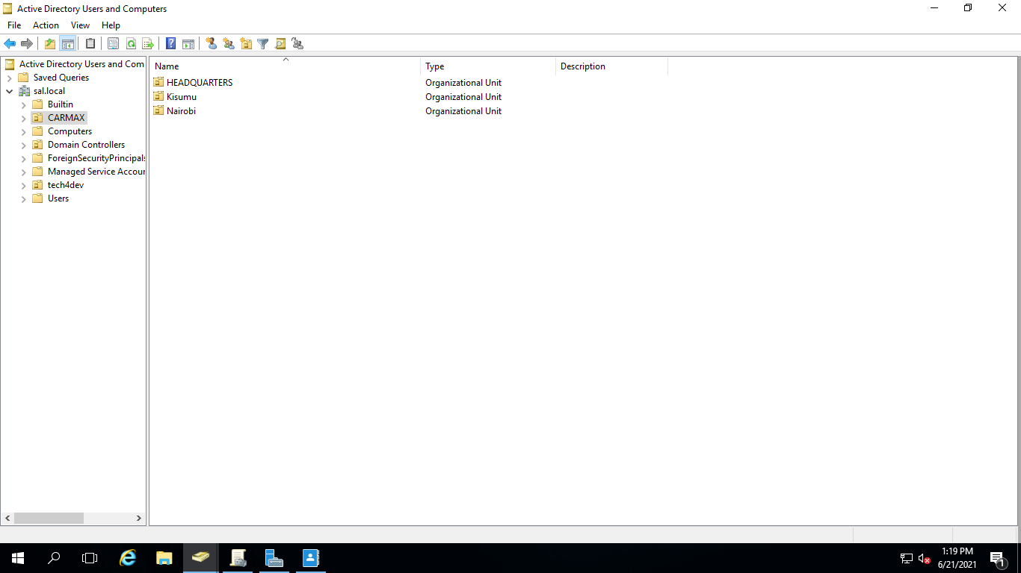

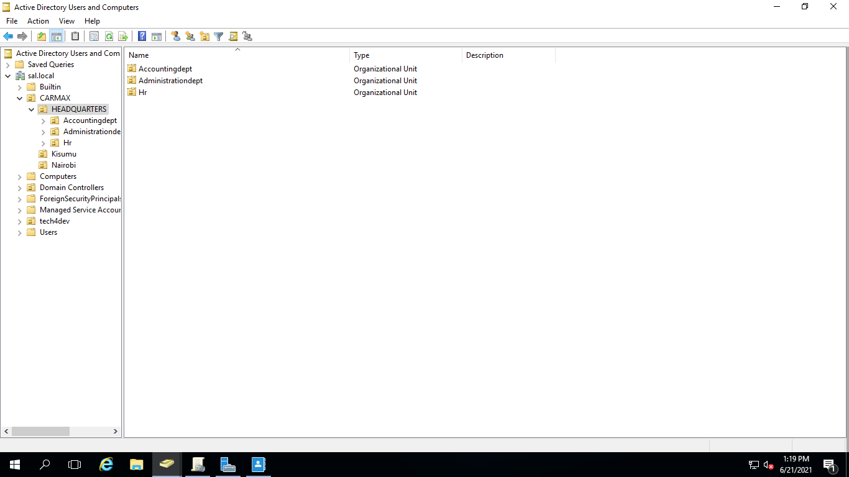

In each location I added groups of sales staff, mechanic staff and the management

For Nairobi :

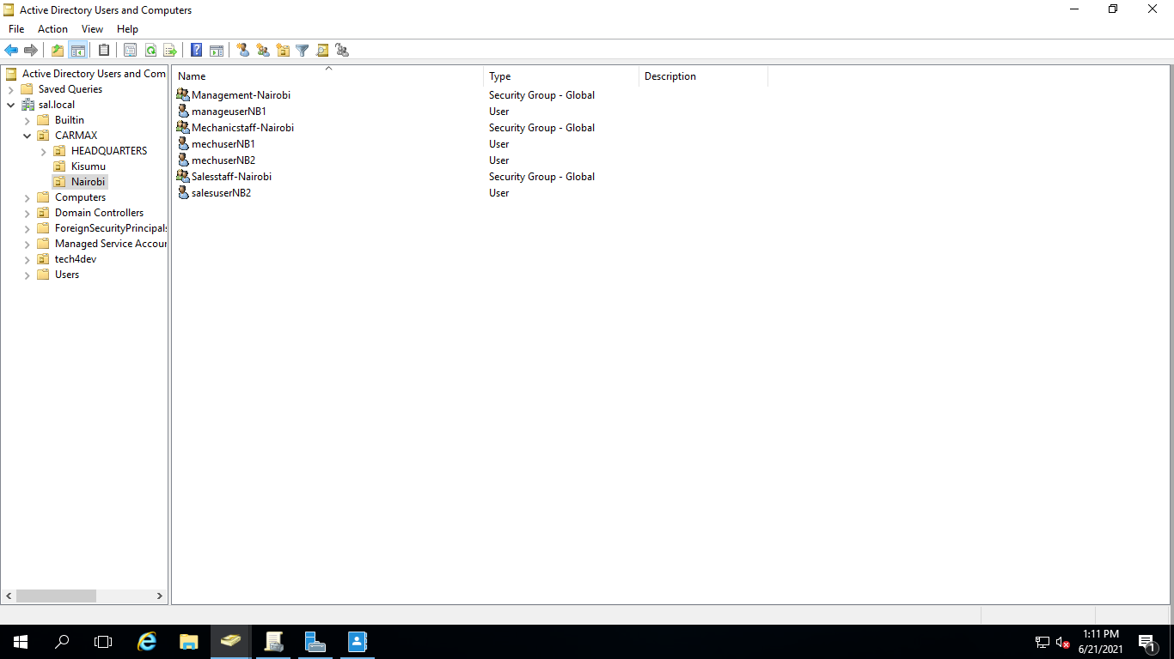

For Kisumu:

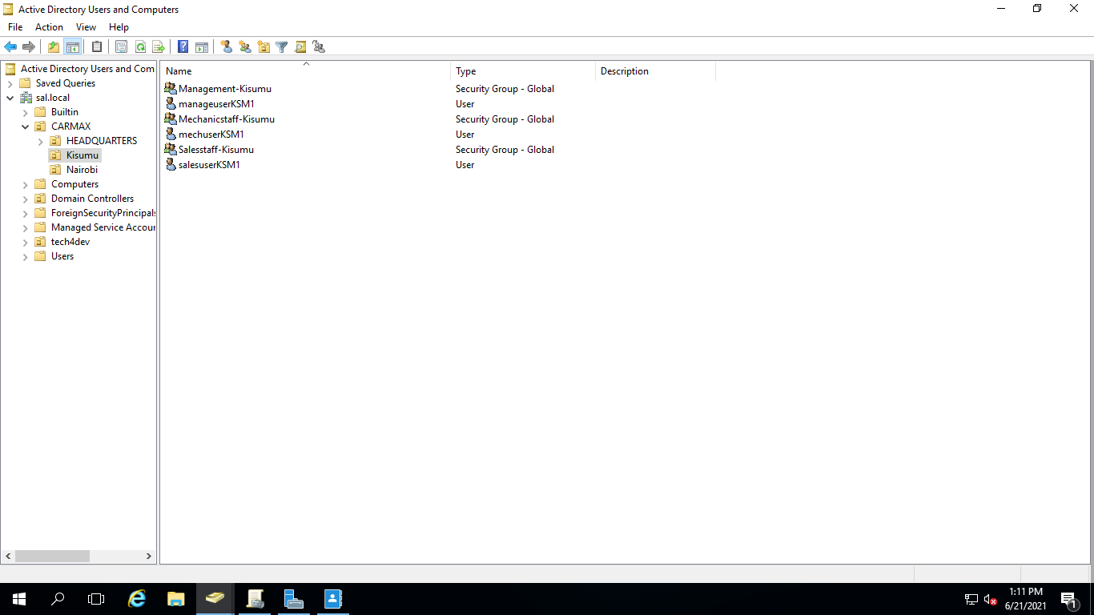

1. **Under each Unit add dummy users.**

In all groups and organizational units I added at least one user.

Rose in administration dept.

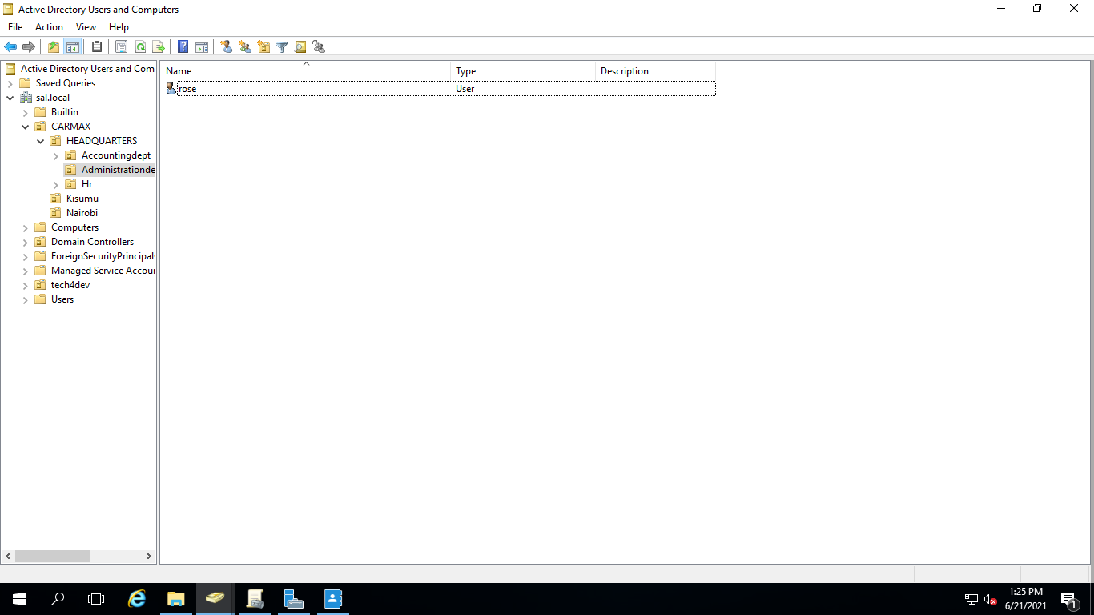

Selina in HR.

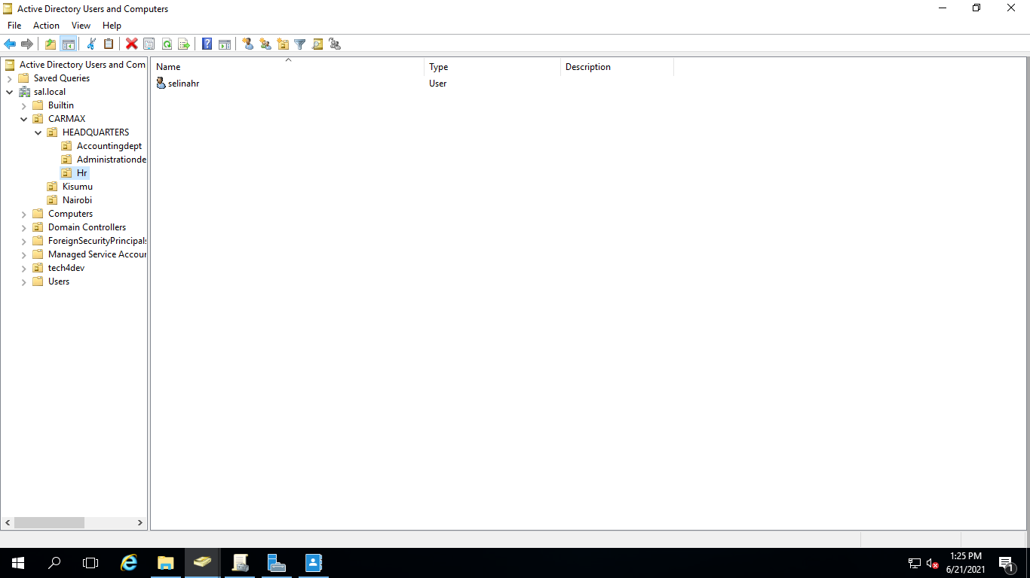

Kriss in accounting department.

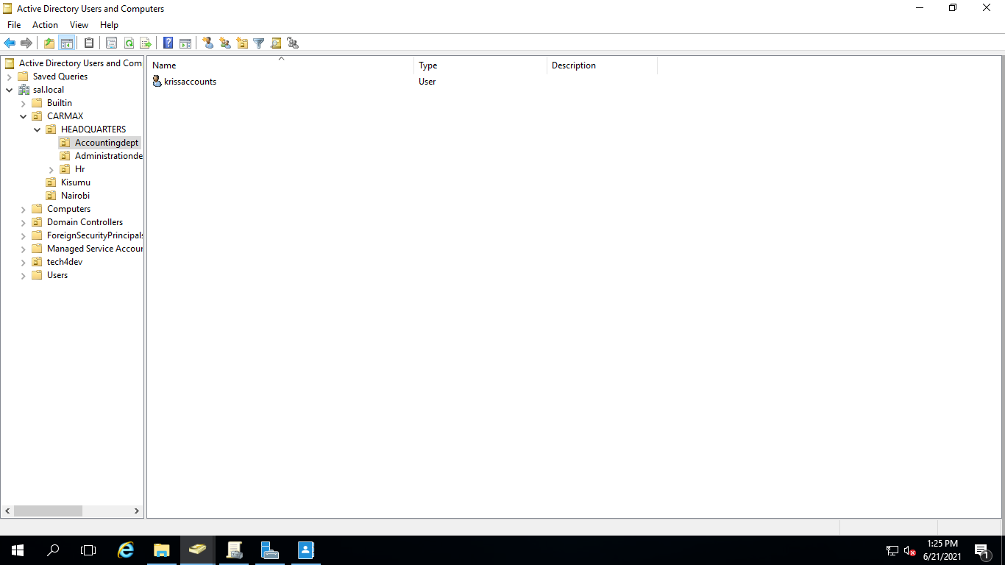

For Nairobi I added the following users:



For Kisumu I added the following users:



1. **Assuming a user in Sales Staff is promoted to Administrative Dept, give a description on how you will handle this and make sure the sales user is effectively transitioned to Administrative Unit**. *Please give a detailed description with accompanied screenshots.*

So I transferred salesuserNB1 to administrative department by right clicking on it and selecting move then choosing administrative department.

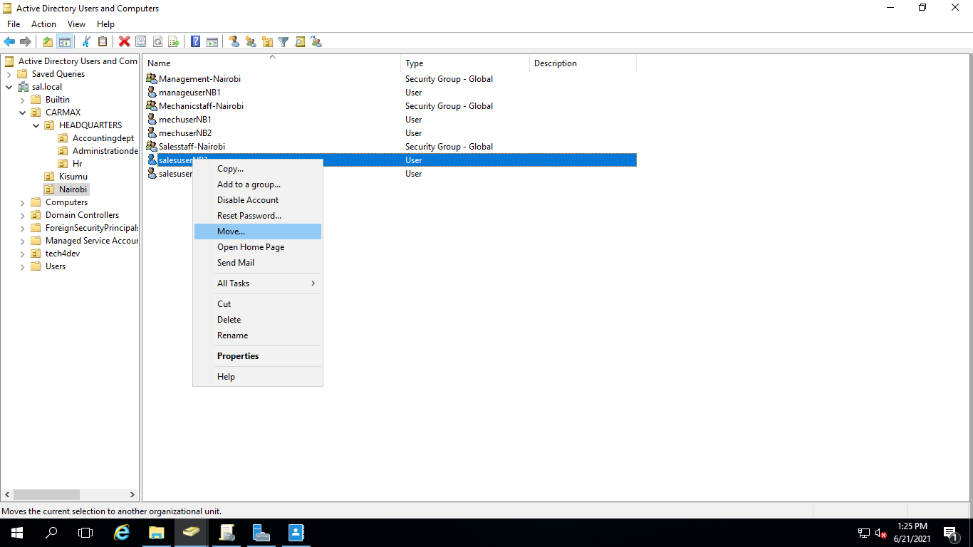

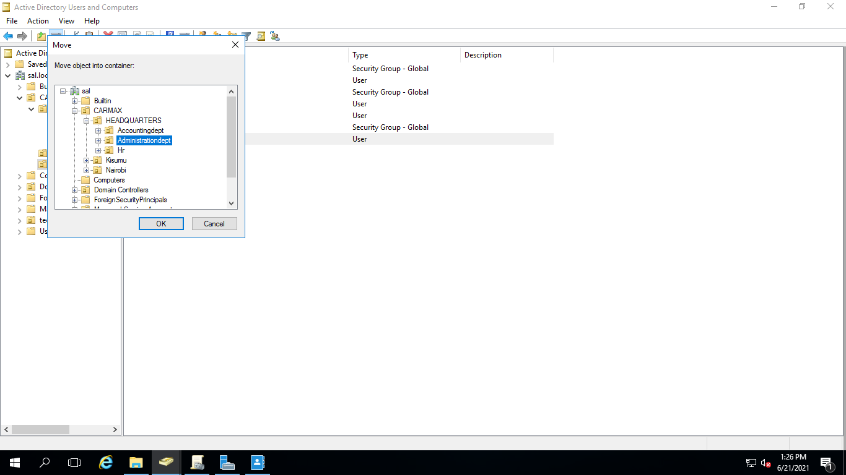

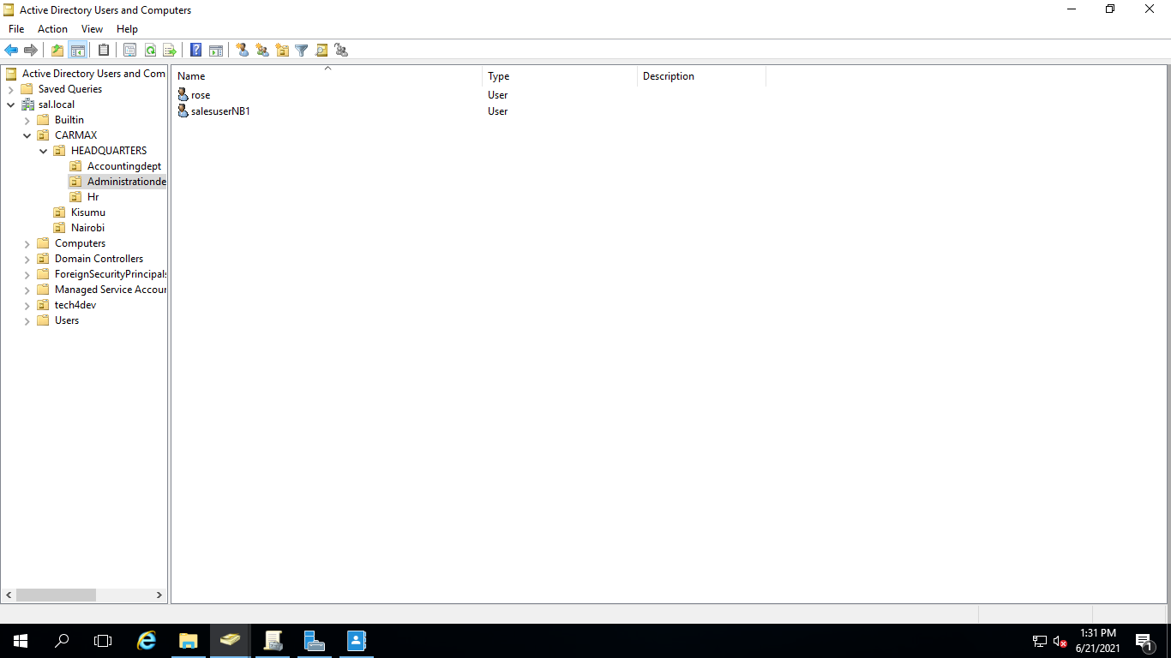

1. **Assuming “One dummy” user in Mechanic Staff has gone on leave for one month, give a detailed description of how you will ensure their user account is inactive and cannot be accessed by any other person during this one-month leave. This is to ensure unauthorized users to do not use that account to access the organization system.**

I will go to the users account and disable it then enable it when they are back. There are two ways to go about this that I know of :

* 1. Right click on the user then selecting disable.

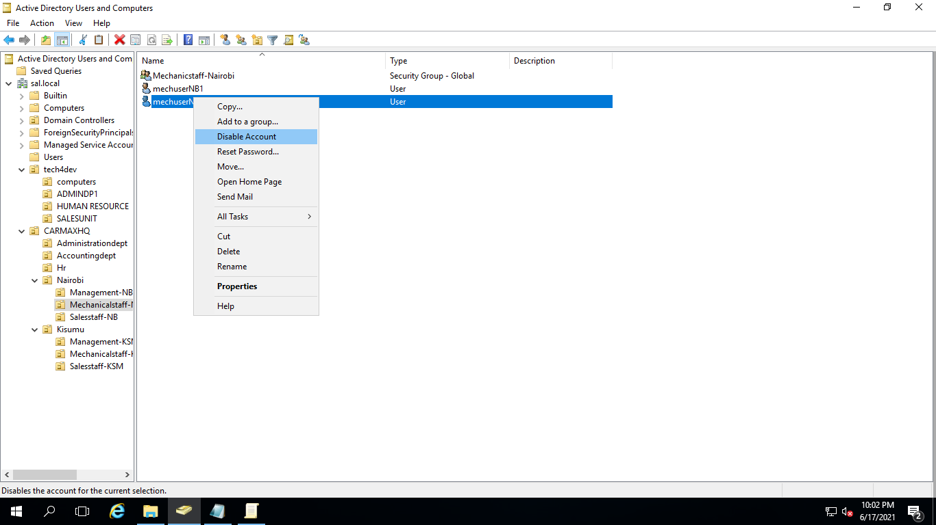

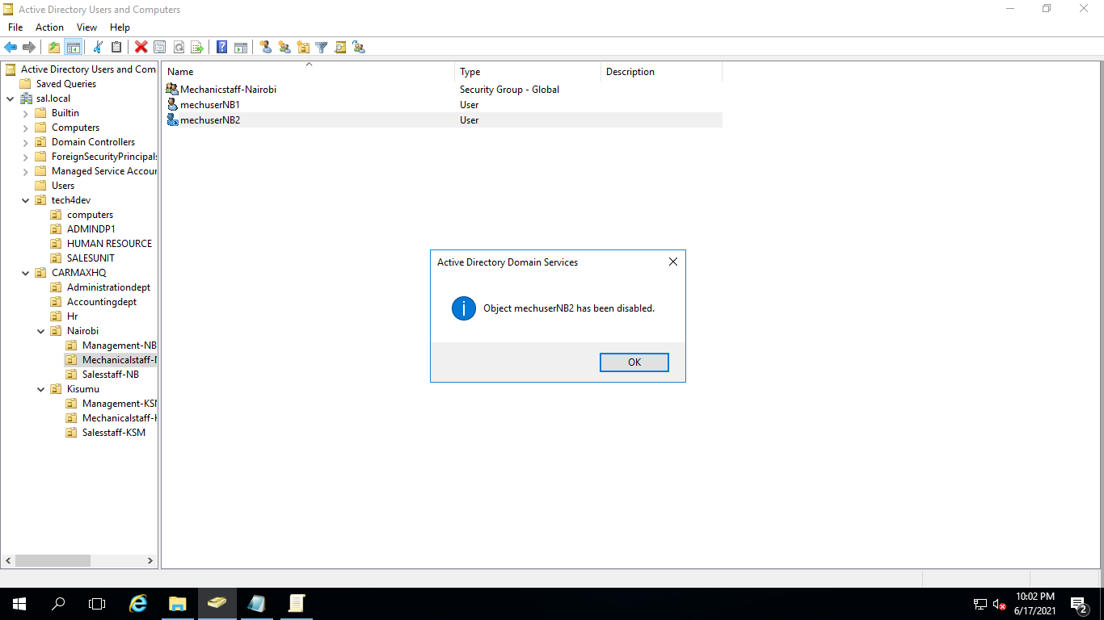

* 1. Right click go to properties and select accounts then go and check the checkbox for disabling.

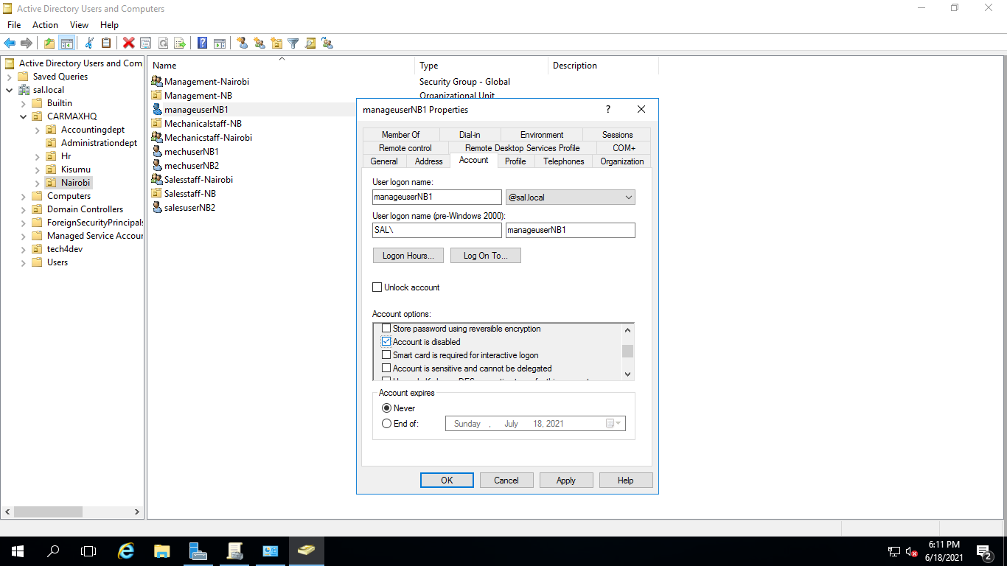

1. **In accounting Dept, we want to maintain high notes of security especially to the computers. Add a computer policy under Accounting Dept to ensure all computers are locked or disabled after 3 minutes of inactivity. The user has to login once again when back.**

To add the policy I went to server manager then tools then group policy management. I right clicked on Accounting department under HEADQUARTERS in CARMAX then created a policy called inactivitytimeout. I right clicked on inactivitytimeout to edit it and change the interactive logon: machine inactivity limit properties to 3 minutes (180secs).

